Sacral plexus

Area of distribution
- Posterior thigh
- Most of the lower leg and foot,
- Part of the pelvis

Location and exit
It’s a part of lumbosacral plexus
Emerges from lumbar and sacral vertebrae (L4 to S4)
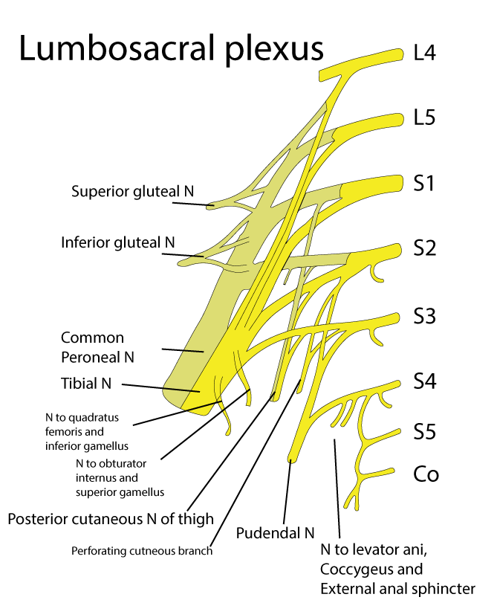

Formation
Sacral plexus is formed by
- Lumbosacral trunk
- Anterior division of the first sacral nerve
- Portions of the anterior divisions of the second and third sacral nerves

Relations
Important relations are
Posterior - piriformis muscle and pelvic fascia
Anterior - internal iliac artery, internal iliac vein, ureter and sigmoid colon
Superior gluteal artery runs between the lumbosacral trunk and S1
Interior gluteal artery runs between S2 and S3

Nerves of sacral plexus
- Superior gluteal nerve (L4-S1) - supply gluteus medius, minimus and tensor fasciae lata
- Inferior gluteal nerve (L5-S2) - supply gluteus maximus
- Posterior cutaneous nerve of thigh (S1-S3) - skin of the back of the thigh

Direct branches from the plexus
- Nerve to piriformis (S1, S2)
- Nerve to obturator internus (L5, S1, S2)
- Nerve to quadratus femoris (L4, L5, S1)

Pudendal and coccygeal nerves
- Pudendal nerve (S2 - S4)
- Coccygeal plexus (S5 - Co1)
Sciatic nerve and its components

Clinical importance - injury to sacral plexus
Most common injury to the sacral plexus is the road traffic accident
The clinical outcome depends on the nerve injured

